Supporting Information (S1)
Mathematical Equation

$$Accuracy= \frac{(TP + TN)}{(TP + TN + FP + FN)}$$ | SE (1)
$$Precision= \frac{TP}{(TP + FP )}$$ | SE (2)
$$Recall (TPR)= \frac{TP}{(TP + FN)}$$ | SE (3)
$$F1-Score=2 . \frac{Precision.Recall}{Precision+Recall}$$ | SE (4)
$$FPR= \frac{FP}{(FP + TN )}$$ | SE (5)
$$ROC-AUC=\int_{0}^{1}{}TPR d(FPR)$$ | SE (6)
$$Confusion Matrix in scikit learn=\left[TN FP FN TP \right]$$  (Where TP = true positives, TN = true negatives, FP = false positives, FN = false negatives) | SE (7)
$$TNR= \frac{TN}{(TN+ FP)}$$ | SE (8)

Table
Supplementary Table 1: Performance of Tree-based and Kernel-based Models.
Model Name | Descriptor | Accuracy | Precision | Recall | F1-score | ROC-AUC | Confusion Matrix
RF Tree | T1 | 0.8333 | 0.8521 | 0.8700 | 0.8608 | 0.9006 | $$\left[151 43 37 249 \right]$$
 | T2 | 0.8354 | 0.8532 | 0.8741 | 0.8636 | 0.9045 | $$\left[151 43 36 250 \right]$$
 | T3 | 0.8438 | 0.8576 | 0.8846 | 0.8709 | 0.9082 | $$\left[152 42 33 253 \right]$$
 | T4 | 0.8333 | 0.8503 | 0.8741 | 0.8621 | 0.9006 | $$\left[150 43 36 250 \right]$$
 | T5 | 0.8333 | 0.8552 | 0.8671 | 0.8611 | 0.9006 | $$\left[152 42 38 248 \right]$$
Extra Trees | T1 | 0.8375 | 0.8562 | 0.8741 | 0.8651 | 0.8755 | $$\left[152 42 36 250 \right]$$
 | T2 | 0.8375 | 0.8586 | 0.8706 | 0.8646 | 0.8755 | $$\left[153 41 37 249 \right]$$
 | T3 | 0.8354 | 0.8557 | 0.8706 | 0.8631 | 0.8753 | $$\left[152 42 37 249 \right]$$
 | T4 | 0.8271 | 0.8512 | 0.8601 | 0.8557 | 0.8684 | $$\left[151 43 40 246 \right]$$
 | T5 | 0.8375 | 0.8537 | 0.8776 | 0.8655 | 0.8759 | $$\left[151 43 35 251 \right]$$
SVM | T1 | 0.8229 | 0.8430 | 0.8636 | 0.8532 | 0.8934 | $$\left[148 46 39 247 \right]$$
 | T2 | 0.8396 | 0.8667 | 0.8636 | 0.8651 | 0.9038 | $$\left[156 38 39 247 \right]$$
 | T3 | 0.8250 | 0.8483 | 0.8601 | 0.8542 | 0.8940 | $$\left[150 44 40 246 \right]$$
 | T4 | 0.8396 | 0.8382 | 0.9056 | 0.8706 | 0.8950 | $$\left[144 50 27 259 \right]$$
 | T5 | 0.8458 | 0.8605 | 0.8846 | 0.8605 | 0.9050 | $$\left[153 41 33 253 \right]$$
Gradient Boosting | T1 | 0.8438 | 0.8505 | 0.8951 | 0.8722 | 0.9036 | $\left[149 45 30 256 \right]$
 | T2 | 0.8230 | 0.8387 | 0.8700 | 0.8540 | 0.8956 | $\left[146 48 37 249 \right]$
 | T3 | 0.8396 | 0.8519 | 0.8846 | 0.8679 | 0.8993 | $\left[150 44 33 253 \right]$
 | T4 | 0.8250 | 0.8412 | 0.8700 | 0.8554 | 0.8892 | $\left[147 47 37 249 \right]$
 | T5 | 0.8354 | 0.8485 | 0.8811 | 0.8642 | 0.8982 | $\left[149 45 34 252 \right]$
XGBoosting | T1 | 0.8333 | 0.8552 | 0.8671 | 0.8611 | 0.9085 | $\left[152 42 38 249 \right]$
 | T2 | 0.8354 | 0.8508 | 0.8776 | 0.8640 | 0.9105 | $\left[150 44 35 251 \right]$
 | T3 | 0.8458 | 0.8557 | 0.8916 | 0.8738 | 0.9075 | $$\left[151 43 31 255 \right]$$
 | T4 | 0.8292 | 0.8400 | 0.8811 | 0.8600 | 0.9034 | $\left[146 48 34 252 \right]$
 | T5 | 0.8333 | 0.8456 | 0.8811 | 0.8630 | 0.9076 | $\left[148 46 34 252 \right]$
LightGBM | T1 | 0.8458 | 0.8630 | 0.8811 | 0.8720 | 0.9094 | $\left[154 40 34 252 \right]$
 | T2 | 0.8417 | 0.8571 | 0.8811 | 0.8690 | 0.9088 | $$\left[152 42 34 252 \right]$$
 | T3 | 0.8375 | 0.8776 | 0.8846 | 0.8648 | 0.9034 | $\left[151 43 35 251 \right]$
 | T4 | 0.8299 | 0.8407 | 0.8671 | 0.8536 | 0.9014 | $\left[148 46 34 252 \right]$
 | T5 | 0.8333 | 0.8480 | 0.8776 | 0.8625 | 0.9027 | $\left[147 47 38 248 \right]$
AdaBoost | T1 | 0.7021 | 0.7299 | 0.7937 | 0.7605 | 0.7992 | $$\left[110 84 59 227 \right]$$
 | T2 | 0.7250 | 0.7484 | 0.8112 | 0.7785 | 0.8101 | $$\left[116 78 54 232 \right]$$
 | T3 | 0.7229 | 0.7284 | 0.8531 | 0.7858 | 0.8085 | $\left[103 91 42 244 \right]$
 | T4 | 0.7521 | 0.7634 | 0.8462 | 0.8027 | 0.8383 | $\left[119 75 44 242 \right]$
 | T5 | 0.7583 | 0.7760 | 0.8357 | 0.8047 | 0.8447 | $\left[125 69 47 239 \right]$
kNN | T1 | 0.8375 | 0.8399 | 0.8986 | 0.8682 | 0.8899 | $$\left[145 49 29 257 \right]$$
 | T2 | 0.8417 | 0.8454 | 0.8986 | 0.8712 | 0.8881 | $\left[147 47 29 257 \right]$
 | T3 | 0.7042 | 0.7118 | 0.8462 | 0.7732 | 0.7781 | $$\left[96 98 44 242 \right]$$
 | T4 | 0.7667 | 0.7702 | 0.8671 | 0.8158 | 0.8331 | $\left[120 74 38 248 \right]$
 | T5 | 0.7667 | 0.7702 | 0.8671 | 0.8158 | 0.8331 | $\left[120 74 38 248 \right]$
DNN | T1 | 0.8104 | 0.8397 | 0.8427 | 0.8412 | 0.8830 | $$\left[148 46 45 241 \right]$$
 | T2 | 0.8063 | 0.8386 | 0.8357 | 0.8371 | 0.8824 | $$\left[148 46 47 239 \right]$$
 | T3 | 0.8083 | 0.8299 | 0.8531 | 0.8414 | 0.8827 | $$\left[144 50 42 244 \right]$$
 | T4 | 0.8229 | 0.8274 | 0.8881 | 0.8567 | 0.8845 | $$\left[141 53 32 254 \right]$$
 | T5 | 0.8438 | 0.8552 | 0.8881 | 0.8714 | 0.8939 | $$\left[151 43 32 254 \right]$$

Supplementary Table 2: Statistical significance for overall performance.
Target | Model | 95% CI Lower | 95% CI Upper
BACE1 | Random Forest | 0.0079 | 0.0155
 | Extra Trees | 0.0088 | 0.0146
 | Gradient Boosting | 0.0088 | 0.0199
 | XGBoost | 0.0075 | 0.0159
 | LightGBM | 0.0071 | 0.0118
AChE | Random Forest | 0.0074 | 0.0148
 | Extra Trees | 0.0081 | 0.0142
 | Gradient Boosting | 0.0084 | 0.0187
 | XGBoost | 0.0072 | 0.0151
 | LightGBM | 0.0069 | 0.0112
MAO-B | Random Forest | 0.0068 | 0.0141
 | Extra Trees | 0.0075 | 0.0136
 | Gradient Boosting | 0.0079 | 0.0178
 | XGBoost | 0.0069 | 0.0145
 | LightGBM | 0.0063 | 0.0109
SERT | Random Forest | 0.0065 | 0.0138
 | Extra Trees | 0.0071 | 0.0132
 | Gradient Boosting | 0.0076 | 0.0171
 | XGBoost | 0.0064 | 0.0140
 | LightGBM | 0.0060 | 0.0105
Dopamine D2 Receptor | Random Forest | 0.0062 | 0.0135
 | Extra Trees | 0.0069 | 0.0129
 | Gradient Boosting | 0.0072 | 0.0165
 | XGBoost | 0.0061 | 0.0136
 | LightGBM | 0.0058 | 0.0101
GABA-A Receptor | Random Forest | 0.0059 | 0.0131
 | Extra Trees | 0.0065 | 0.0125
 | Gradient Boosting | 0.0069 | 0.0158
 | XGBoost | 0.0058 | 0.0130
 | LightGBM | 0.0054 | 0.0098
5-HT1A Receptor | Random Forest | 0.0061 | 0.0133
 | Extra Trees | 0.0068 | 0.0128
 | Gradient Boosting | 0.0071 | 0.0162
 | XGBoost | 0.0060 | 0.0132
 | LightGBM | 0.0057 | 0.0100
EGFR | Random Forest | 0.0057 | 0.0127
 | Extra Trees | 0.0062 | 0.0121
 | Gradient Boosting | 0.0067 | 0.0152
 | XGBoost | 0.0055 | 0.0125
 | LightGBM | 0.0051 | 0.0094

Supplementary Table 3: Statistical significance for Specificity (TNR).
Target | Model | 95% CI Lower | 95% CI Upper
BACE1 | Random Forest | 0.0035 | 0.0174
 | Extra Trees | 0.0045 | 0.0143
 | Gradient Boosting | 0.0197 | 0.0349
 | XGBoost | 0.0091 | 0.0210
 | LightGBM | 0.0173 | 0.0243
AChE | Random Forest | 0.0032 | 0.0165
 | Extra Trees | 0.0041 | 0.0138
 | Gradient Boosting | 0.0185 | 0.0336
 | XGBoost | 0.0084 | 0.0201
 | LightGBM | 0.0164 | 0.0234
MAO-B | Random Forest | 0.0030 | 0.0158
 | Extra Trees | 0.0039 | 0.0132
 | Gradient Boosting | 0.0178 | 0.0325
 | XGBoost | 0.0080 | 0.0192
 | LightGBM | 0.0158 | 0.0226
SERT | Random Forest | 0.0028 | 0.0152
 | Extra Trees | 0.0037 | 0.0127
 | Gradient Boosting | 0.0171 | 0.0314
 | XGBoost | 0.0076 | 0.0185
 | LightGBM | 0.0151 | 0.0218
Dopamine D2 Receptor | Random Forest | 0.0027 | 0.0148
 | Extra Trees | 0.0035 | 0.0121
 | Gradient Boosting | 0.0165 | 0.0306
 | XGBoost | 0.0072 | 0.0179
 | LightGBM | 0.0145 | 0.0210
GABA-A Receptor | Random Forest | 0.0025 | 0.0142
 | Extra Trees | 0.0032 | 0.0118
 | Gradient Boosting | 0.0157 | 0.0294
 | XGBoost | 0.0068 | 0.0171
 | LightGBM | 0.0138 | 0.0202
5-HT1A Receptor | Random Forest | 0.0026 | 0.0145
 | Extra Trees | 0.0034 | 0.0120
 | Gradient Boosting | 0.0160 | 0.0299
 | XGBoost | 0.0070 | 0.0174
 | LightGBM | 0.0141 | 0.0205
EGFR | Random Forest | 0.0023 | 0.0138
 | Extra Trees | 0.0030 | 0.0112
 | Gradient Boosting | 0.0151 | 0.0287
 | XGBoost | 0.0064 | 0.0165
 | LightGBM | 0.0132 | 0.0194

Supplementary Table 4: Five folds cross-validation of Meta-Ensemble Model.
Descriptor Name | Accuracy | Precision | Recall | F1- score | ROC-AUC | Confusion Matrix
T1 | 0.8303 | 0.8502 | 0.8688 | 0.8589 | 0.9050 | $$\left[602 176 150 993 \right]$$
T2 | 0.8282 | 0. 8476 | 0. 8679 | 0. 8573 | 0. 9058 | $$\left[599 179 151 992 \right]$$
T3 | 0.8308 | 0. 8506 | 0. 8688 | 0. 8593 | 0. 9033 | $$\left[603 175 150 993 \right]$$
T4 | 0. 8272 | 0. 8418 | 0. 8753 | 0. 8577 | 0. 8853 | $$\left[589 189 143 1000 \right]$$
T5 | 0. 8298 | 0. 8449 | 0. 8761 | 0. 8598 | 0. 8912 | $$\left[593 185 142 1001 \right]$$
Supplementary Table 5: Y randomized value (n=100) results.
Model Type | Accuracy | F1-Score | ROC-AUC
Original Meta-Ensemble | 0.8471 | 0.8681 | 0.9138
Y-Randomized (N = 100) | 0.5355 ± 0.0267 | 0.6427 ± 0.0230 | 0.4983 ± 0.0352
Empirical p-values (N= 100) | 0.009 | 0.009 | 0.009
Y-Randomized (N = 500) | 0.5246 ± 0.0148 | 0.6279 ± 0.0126 | 0.4876 ± 0.0173
Empirical p-values (N =500) | 0.004 | 0.006 | 0.018

Supplementary Table 6: Descriptor-Paired Statistical Comparison between Internal and External Validation Sets.
Metric | Internal Mean | External Mean | Mean Difference (Internal − External) | 95% Bootstrap CI
Accuracy | 0.8471 | 0.8136 | 0.0335 | [0.0312, 0.0359]
Precision | 0.8617 | 0.8135 | 0.0482 | [0.0441, 0.0523]
Recall | 0.8748 | 0.8424 | 0.0324 | [0.0301, 0.0350]
F1-score | 0.8681 | 0.8313 | 0.0415 | [0.0390, 0.0443]
ROC-AUC | 0.9138 | 0.8780 | 0.0358 | [0.0320, 0.0390]

Supplementary Table 7: SHAP analysis using T1 descriptor
Model | Feature | Substructure | Interpretation
Random Forest | Feature378 | — | Rare / unstable bit
 | Feature1535 | ccn | Heteroaromatic → π–π + H-bond acceptor
 | Feature1452 | cnc | Aromatic heterocycle
 | Feature486 | C(N)=O | Amide → H-bond donor/acceptor
 | Feature1019 | NC(c)=N | Amidine → strong interaction
 | Feature1978 | NC(c)=O | Aromatic amide
 | Feature1146 | sulfone-like | Polar pharmacophore
 | Feature855 | cc(C)n | Substituted aromatic
 | Feature894 | CNCCN | Flexible amine chain
 | Feature873 | aromatic + NH | Mixed π + H-bond
Extra Trees | Feature1535 | ccn | Core aromatic binding
 | Feature1452 | cnc | Heterocycle
 | Feature486 | C(N)=O | Amide
 | Feature1019 | NC(c)=N | Strong H-bond
 | Feature1978 | NC(c)=O | Stabilizing interaction
 | Feature855 | cc(C)n | Hydrophobic + aromatic
 | Feature894 | CNCCN | Flexibility
 | Feature873 | aromatic + NH | Mixed interaction
 | Feature843 | aromatic fragment | Hydrophobic core
 | Feature255 | small polar group | Auxiliary interaction
LightGBM | Feature1019 | NC(c)=N | Strong interaction (key)
 | Feature1978 | NC(c)=O | Amide
 | Feature1146 | sulfone-like | High polarity
 | Feature894 | CNCCN | Flexibility
 | Feature855 | cc(C)n | Aromatic
 | Feature1928 | polar fragment | Solubility tuning
 | Feature1199 | small polar | Interaction fine-tuning
 | Feature1152 | hetero fragment | Binding specificity
 | Feature1060 | polar chain | Adaptability
 | Feature1574 | substituted aromatic | Affinity modulation
XGBoost | Feature1535 | ccn | Core scaffold
 | Feature1452 | cnc | Heterocycle
 | Feature1019 | NC(c)=N | Strong binding
 | Feature1978 | NC(c)=O | Stabilization
 | Feature486 | C(N)=O | Amide
 | Feature873 | aromatic + NH | Dual interaction
 | Feature843 | aromatic | Hydrophobic
 | Feature255 | polar | Secondary interaction
 | Feature554 | hydrophobic fragment | Pocket fitting
 | Feature1895 | bulky group | Steric tuning
Gradient Boosting | Feature1535 | ccn | Core aromatic
 | Feature1452 | cnc | Binding core
 | Feature486 | C(N)=O | Amide
 | Feature1019 | NC(c)=N | Strong interaction
 | Feature1978 | NC(c)=O | Stability
 | Feature855 | cc(C)n | Aromatic
 | Feature873 | aromatic + NH | Mixed
 | Feature843 | aromatic | Hydrophobic
 | Feature255 | polar | Minor interaction
 | Feature1199 | small polar | Fine tuning
Meta Ensemble | Feature1535 | ccn | π–π + H-bond acceptor
 | Feature1452 | cnc | Binding scaffold
 | Feature1019 | NC(c)=N | Strong ionic/H-bond
 | Feature1978 | NC(c)=O | Directional H-bond
 | Feature486 | C(N)=O | Donor/acceptor
 | Feature855 | cc(C)n | Hydrophobic + π
 | Feature873 | aromatic + NH | Mixed interaction
 | Feature894 | CNCCN | Flexible binding
 | Feature1146 | sulfone-like | Polarity
 | Feature1199 | small polar | Fine tuning

Supplementary Table 8: SHAP analysis using T2 descriptor
Model | Feature | Substructure | Interpretation
Random Forest | Bit_871 | heteroaromatic | Core binding scaffold
 | Bit_378 | — | Rare / unstable
 | Bit_955 | aromatic | Hydrophobic core
 | Bit_816 | substituted aromatic | Affinity tuning
 | Bit_511 | amine | Polar interaction
 | Bit_718 | heterocycle | Binding
 | Bit_539 | aromatic | π–π interaction
 | Bit_94 | small fragment | Weak
 | Bit_428 | polar chain | Flexibility
 | Bit_486 | amide | Strong H-bond
Extra Trees | Bit_871 | heteroaromatic | Core scaffold
 | Bit_955 | aromatic | Hydrophobic
 | Bit_816 | substituted aromatic | Binding tuning
 | Bit_511 | amine | Polar
 | Bit_718 | heterocycle | Binding
 | Bit_539 | aromatic | Core
 | Bit_428 | polar chain | Flexibility
 | Bit_954 | aromatic + group | Affinity
 | Bit_695 | hetero fragment | Specificity
 | Bit_486 | amide | Strong interaction
LightGBM | Bit_511 | amine | Flexibility + charge
 | Bit_428 | polar chain | Adaptability
 | Bit_695 | hetero fragment | Specificity
 | Bit_585 | aromatic + hetero | π + H-bond
 | Bit_216 | polar | Solubility
 | Bit_490 | amide-like | H-bond
 | Bit_980 | bulky | Steric fit
 | Bit_904 | aromatic polar | Mixed
 | Bit_191 | small polar | Fine tuning
 | Bit_486 | amide | Strong interaction
XGBoost | Bit_871 | heteroaromatic | Core scaffold
 | Bit_955 | aromatic | Hydrophobic
 | Bit_816 | substituted aromatic | Binding
 | Bit_718 | heterocycle | Interaction
 | Bit_539 | aromatic | Core
 | Bit_954 | aromatic + group | Affinity
 | Bit_585 | hetero aromatic | Mixed
 | Bit_360 | aromatic | Core
 | Bit_490 | amide-like | Interaction
 | Bit_486 | amide | Strong H-bond
Gradient Boosting | Bit_871 | heteroaromatic | Core
 | Bit_955 | aromatic | Hydrophobic
 | Bit_816 | substituted aromatic | Binding
 | Bit_511 | amine | Polar
 | Bit_718 | heterocycle | Interaction
 | Bit_539 | aromatic | Core
 | Bit_360 | aromatic | Scaffold
 | Bit_216 | polar | Solubility
 | Bit_191 | small polar | Fine tuning
 | Bit_486 | amide | Strong
Meta Ensemble | Bit_871 | heteroaromatic | Core scaffold
 | Bit_955 | aromatic | Hydrophobic
 | Bit_816 | substituted aromatic | Binding tuning
 | Bit_718 | heterocycle | Interaction
 | Bit_539 | aromatic | Core
 | Bit_511 | amine | Flexibility
 | Bit_428 | polar chain | Adaptability
 | Bit_585 | hetero aromatic | Mixed
 | Bit_490 | amide-like | H-bond
 | Bit_486 | amide | Strong interaction

Supplementary Table 9: SHAP analysis using T3 descriptor
Model | Feature | Substructure | Interpretation
Random Forest | MW | — | Molecular size
 | Bit_1535 | ccn | Core heteroaromatic scaffold
 | HeavyAtoms | — | Molecular complexity
 | Bit_1203 | aromatic | Hydrophobic interaction
 | Bit_718 | heterocycle | Binding scaffold
 | LogP | — | Lipophilicity
 | HBA | — | H-bond acceptor
 | Bit_191 | polar fragment | Secondary interaction
 | TPSA | — | Polarity
 | RotB | — | Flexibility
Extra Trees | Bit_1535 | ccn | Core binding
 | Bit_718 | heterocycle | Interaction
 | Bit_1203 | aromatic | Hydrophobic
 | Bit_191 | polar | Fine tuning
 | Bit_1840 | substituted aromatic | Affinity
 | Bit_1738 | bulky fragment | Steric fit
 | Bit_1136 | hetero fragment | Specificity
 | Bit_980 | bulky | Pocket filling
 | Bit_1816 | aromatic | Core
 | Bit_1895 | hydrophobic fragment | Shape complementarity
LightGBM | LogP | — | Lipophilicity
 | TPSA | — | Polarity
 | HBA | — | H-bonding
 | RotB | — | Flexibility
 | Bit_191 | polar | Interaction
 | Bit_1136 | hetero fragment | Specific binding
 | Bit_1860 | polar bulky | Selectivity
 | Bit_980 | bulky | Steric fit
 | Bit_622 | aromatic polar | Mixed
 | Bit_11 | small fragment | Fine tuning
XGBoost | Bit_1535 | ccn | Core scaffold
 | Bit_718 | heterocycle | Binding
 | Bit_1203 | aromatic | Hydrophobic
 | Bit_1840 | substituted aromatic | Affinity
 | Bit_1738 | bulky | Steric
 | Bit_1136 | hetero fragment | Specificity
 | Bit_980 | bulky | Fit
 | Bit_622 | aromatic polar | Mixed
 | Bit_1816 | aromatic | Core
 | Bit_1895 | hydrophobic | Pocket interaction
Gradient Boosting | MW | — | Size
 | LogP | — | Lipophilicity
 | TPSA | — | Polarity
 | HBA | — | H-bond
 | Bit_1535 | ccn | Core scaffold
 | Bit_718 | heterocycle | Binding
 | Bit_191 | polar | Secondary
 | Bit_1136 | hetero | Specific
 | Bit_980 | bulky | Fit
 | Bit_1816 | aromatic | Core
Meta Ensemble | Bit_1535 | ccn | Core heteroaromatic
 | Bit_718 | heterocycle | Binding scaffold
 | Bit_191 | polar | Interaction tuning
 | Bit_980 | bulky | Pocket fit
 | Bit_1203 | aromatic | Hydrophobic
 | LogP | — | Lipophilicity
 | TPSA | — | Polarity
 | HBA | — | H-bond
 | RotB | — | Flexibility
 | MW | — | Size
Supplementary Table 10: SHAP analysis using T4 descriptor
Model | Feature | Substructure | Interpretation
Random Forest | ATS3dv | — | Molecular size
 | IC1 | — | Structural complexity
 | GGI7 | — | Electron distribution
 | MDEC-33 | — | Connectivity
 | SlogP_VSA3 | — | Lipophilicity
 | IC2 | — | Diversity
 | BCUTd-1l | — | Reactivity
 | MDEN-33 | — | Shape
 | JGI6 | — | Interaction potential
 | n6HRing | aromatic ring | π–π stacking
Extra Trees | GGI7 | — | Binding interactions
 | MDEC-33 | — | Shape
 | BCUTd-1l | — | Reactivity
 | MDEN-33 | — | Shape
 | JGI6 | — | Interaction
 | n6HRing | aromatic | π–π stacking
 | GGI4 | — | Local interaction
 | MID_O | oxygen | H-bond acceptor
 | MATS3dv | — | Size
 | ETA_beta_ns_d | — | Reactivity
LightGBM | SlogP_VSA3 | — | Membrane permeability
 | BCUTpe-1l | — | Binding flexibility
 | MATS5i | — | Reactivity
 | ATSC7m | — | Size
 | ETA_beta_ns_d | — | Binding strength
 | AMID_N | amide | H-bond donor
 | MINsssCH | sp3 carbon | Hydrophobic
 | MID_O | oxygen | H-bond acceptor
 | GGI10 | — | Delocalization
 | IC2 | — | Diversity
XGBoost | ATS3dv | — | Size
 | IC1 | — | Complexity
 | GGI7 | — | Interaction
 | BCUTd-1l | — | Reactivity
 | JGI6 | — | Binding
 | n6HRing | aromatic | π interaction
 | GGI4 | — | Interaction
 | MATS3dv | — | Size
 | MINsssCH | sp3 carbon | Hydrophobic
 | AMID_N | amide | H-bond
Gradient Boosting | ATS3dv | — | Size
 | IC1 | — | Complexity
 | GGI7 | — | Interaction
 | BCUTd-1l | — | Reactivity
 | JGI6 | — | Binding
 | n6HRing | aromatic | Core
 | MID_O | oxygen | H-bond
 | AMID_N | amide | Interaction
 | ETA_beta_ns_d | — | Binding strength
 | MATS3dv | — | Size
Meta Ensemble | GGI7 | — | Key interaction
 | BCUTd-1l | — | Reactivity
 | JGI6 | — | Interaction strength
 | n6HRing | aromatic | π–π stacking
 | ATS3dv | — | Size
 | IC1 | — | Complexity
 | MID_O | oxygen | H-bond acceptor
 | AMID_N | amide | H-bond donor
 | ETA_beta_ns_d | — | Binding strength
 | SlogP_VSA3 | — | Permeability

Supplementary Table 11: SHAP analysis using T5 descriptor
Model | Feature | Substructure | Interpretation
Random Forest | ATS3dv | — | Molecular size
 | IC1 | — | Structural complexity
 | GGI7 | — | Electron distribution
 | MDEC-33 | — | Connectivity
 | IC2 | — | Diversity
 | SlogP_VSA3 | — | Permeability
 | BCUTd-1l | — | Reactivity
 | Bit_718 | heterocycle | Binding scaffold
 | n6HRing | aromatic ring | π–π interaction
 | JGI6 | — | Interaction strength
Extra Trees | GGI7 | — | Electron flow
 | MDEC-33 | — | Shape
 | BCUTd-1l | — | Reactivity
 | Bit_718 | heterocycle | Binding
 | n6HRing | aromatic | Core scaffold
 | JGI6 | — | Interaction
 | MDEN-33 | — | Shape
 | GGI9 | — | Delocalization
 | Bit_980 | bulky | Steric fit
 | MINsssCH | sp3 carbon | Hydrophobicity
LightGBM | SlogP_VSA3 | — | Membrane permeability
 | PEOE_VSA3 | — | Electrostatic interaction
 | BCUTd-1l | — | Reactivity
 | ETA_beta_ns_d | — | Binding strength
 | MATS5i | — | Electronic behavior
 | ATSC7m | — | Size
 | MATS3dv | — | Shape
 | GGI9 | — | Long-range interaction
 | Bit_980 | bulky | Pocket fit
 | MINsssCH | sp3 carbon | Hydrophobic
XGBoost | ATS3dv | — | Size
 | IC1 | — | Complexity
 | GGI7 | — | Interaction
 | BCUTd-1l | — | Reactivity
 | Bit_718 | heterocycle | Binding
 | n6HRing | aromatic | Core
 | JGI3 | — | Local interaction
 | JGI6 | — | Binding strength
 | Bit_980 | bulky | Steric fit
 | MINsssCH | sp3 carbon | Hydrophobic
Gradient Boosting | ATS3dv | — | Size
 | IC1 | — | Complexity
 | GGI7 | — | Interaction
 | BCUTd-1l | — | Reactivity
 | Bit_718 | heterocycle | Binding
 | n6HRing | aromatic | Core
 | JGI6 | — | Interaction
 | ETA_beta_ns_d | — | Binding strength
 | Bit_980 | bulky | Pocket fit
 | PEOE_VSA3 | — | Electrostatics
Meta Ensemble | GGI7 | — | Key electronic interaction
 | BCUTd-1l | — | Reactivity
 | JGI6 | — | Binding strength
 | Bit_718 | heterocycle | Core scaffold
 | n6HRing | aromatic | π–π interaction
 | Bit_980 | bulky | Steric complementarity
 | SlogP_VSA3 | — | Permeability
 | PEOE_VSA3 | — | Electrostatic binding
 | ETA_beta_ns_d | — | Interaction strength
 | ATS3dv | — | Shape fitting

Supplementary Table 12: TNR of Models for Each Descriptors
Model Name | Descriptor |  | Specificity (TNR)
RF tree | T1 |  | 0.7783
 | T2 |  | 0.7783
 | T3 |  | 0.7835
 | T4 |  | 0.7772
 | T5 |  | 0.7835
Extra trees | T1 |  | 0.7835
 | T2 |  | 0.7783
 | T3 |  | 0.7886
 | T4 |  | 0.7783
 | T5 |  | 0.7783
Gradient Boosting | T1 |  | 0.7680
 | T2 |  | 0.7525
 | T3 |  | 0.7731
 | T4 |  | 0.7577
 | T5 |  | 0.7680
LightGBM | T1 |  | 0.7938
 | T2 |  | 0.7835
 | T3 |  | 0.7783
 | T4 |  | 0.7577
 | T5 |  | 0.7628
XGBoost | T1 |  | 0.7835
 | T2 |  | 0.7731
 | T3 |  | 0.7783
 | T4 |  | 0.7525
 | T5 |  | 0.7628
Supplementary Table 13: TNR of Meta-Ensemble Model
Model Name | Descriptor Name | TNR
Meta-Ensemble | T1 | 0.7986
 | T2 | 0.7938
 | T3 | 0.7989
 | T4 | 0.7793
 | T5 | 0.7835

Supplementary Table 14: Overall Mean Performance of Top Performing Models for Their Descriptors
Model name | Mean accuracy | Mean precision | Mean recall | Mean F1-score | Mean TNR | Mean ROC-AUC
RF tree | 0.83564 | 0.85368 | 0.87398 | 0.8637 | 0.78016 | 0.9029
Extra trees | 0.835 | 0.85508 | 0.8706 | 0.863 | 0.7814 | 0.87412
XGBoost | 0.83336 | 0.84946 | 0.8797 | 0.86438 | 0.77004 | 0.9075
Gradient Boosting | 0.8354 | 0.84616 | 0.88016 | 0.86274 | 0.76386 | 0.89718
LightGBM | 0.83764 | 0.8573 | 0.8783 | 0.8664 | 0.77522 | 0.9051

Supplementary Table 15: Cross-Descriptor Robustness Evaluation
Training Descriptor | Test Descriptor | ROC–AUC | ΔROC–AUC
T1 (ECFP4-2048) | T1 | 0.9174 | —
T1 | T2 (ECFP4-1024) | 0.9065 | -0.0109
T1 | T3 (ECFP4 + props) | 0.8987 | -0.0187
T1 | T4 (Mordred) | 0.8712 | -0.0462
T1 | T5 (Mordred + ECFP4) | 0.8849 | -0.0325

Supplementary Table 16: Descriptor-Space Applicability Domain (Euclidean Distance)
Descriptor | Train Coverage (%) | Test Coverage (%)
T1 | 91.2 | 76.8
T2 | 92.5 | 78.1
T3 | 90.3 | 75.9
T4 | 93.6 | 77.4
T5 | 92.1 | 76.5

Supplementary Table 17. Comparison of training-based and cross-validation-based TNR weighting strategies for the Meta-Ensemble model
Weighting Strategy | TNR Estimation Method | Mean TNR (Weight Derivation) | Std (TNR) | Test Accuracy | Test Precision | Test Recall | Test F1-score | Test ROC–AUC | Test TNR
Training-based weighting | In-sample (training predictions) | 0.781 | 0.012 | 0.8471 | 0.8617 | 0.8748 | 0.8681 | 0.9138 | 0.7732
Cross-validation-based weighting (proposed) | Out-of-fold (5-fold CV) | 0.768 | 0.015 | 0.8458 | 0.8589 | 0.8721 | 0.8654 | 0.9129 | 0.7695

Supplementary Table S18: Threshold Sensitivity Analysis
Threshold (pKᵢ) | Actives (%) | Accuracy | Precision | Recall | F1-score | ROC–AUC
≥ 6.5 | 65.8% | 0.8120 | 0.8512 | 0.9035 | 0.8765 | 0.9032
≥ 7.0 | 59.5% | 0.8471 | 0.8617 | 0.8748 | 0.8681 | 0.9138
≥ 7.5 | 51.2% | 0.8032 | 0.8295 | 0.8126 | 0.8209 | 0.9015

Supplementary Table S19: AD analysis Table
Target | Descriptor | Train Coverage (%) | Test Coverage (%)
BACE1 | T1 | 90.26 | 78.13
 | T2 | 91.46 | 80.00
 | T3 | 89.58 | 77.91
 | T4 | 93.28 | 79.16
 | T5 | 92.45 | 77.70
Acetylcholinesterase (AChE) | T1 | 91.10 | 79.22
 | T2 | 92.35 | 80.41
 | T3 | 90.18 | 78.54
 | T4 | 93.02 | 80.00
 | T5 | 92.47 | 78.96
MAO-B | T1 | 90.84 | 78.95
 | T2 | 91.96 | 79.84
 | T3 | 89.92 | 77.88
 | T4 | 92.85 | 79.43
 | T5 | 91.74 | 78.22
Serotonin Transporter (SERT) | T1 | 90.72 | 78.63
 | T2 | 91.84 | 79.57
 | T3 | 89.75 | 77.50
 | T4 | 92.61 | 79.01
 | T5 | 91.88 | 78.12
Dopamine D2 Receptor | T1 | 90.41 | 78.32
 | T2 | 91.52 | 79.16
 | T3 | 89.66 | 77.44
 | T4 | 92.36 | 78.87
 | T5 | 91.47 | 77.91
GABA-A Receptor | T1 | 89.96 | 77.91
 | T2 | 91.04 | 78.75
 | T3 | 89.12 | 77.08
 | T4 | 91.88 | 78.43
 | T5 | 90.95 | 77.50
5-HT1A Receptor | T1 | 90.25 | 78.11
 | T2 | 91.37 | 79.02
 | T3 | 89.48 | 77.29
 | T4 | 92.21 | 78.74
 | T5 | 91.43 | 77.68
EGFR | T1 | 89.84 | 77.70
 | T2 | 90.96 | 78.54
 | T3 | 88.92 | 76.87
 | T4 | 91.74 | 78.12
 | T5 | 90.88 | 77.29

Supplementary Table S20. Detailed descriptor variability and theoretical variance analysis across descriptor sets and CNS-related therapeutic targets
Target | Descriptor Set | ROC–AUC | Accuracy | ROC–AUC SD | Accuracy SD | Mean Pairwise Correlation (ρ) | Mean Predictor Variance (σ²) | Theoretical Variance Bound | Observed Ensemble Variance
BACE1 | Mean | 0.9199 | 0.8521 | 0.0095 | 0.0054 | 0.9571 | 0.1291 | 0.1247 | 0.1279
Acetylcholinesterase (AChE) | Mean | 0.918 | 0.851 | 0.010 | 0.006 | 0.956 | 0.129 | 0.124 | 0.126
MAO-B | Mean | 0.913 | 0.846 | 0.014 | 0.008 | 0.949 | 0.136 | 0.131 | 0.130
Serotonin Transporter (SERT) | Mean | 0.909 | 0.842 | 0.012 | 0.007 | 0.952 | 0.134 | 0.128 | 0.130
Dopamine D2 Receptor | Mean | 0.904 | 0.836 | 0.016 | 0.009 | 0.944 | 0.141 | 0.136 | 0.138
GABA-A Receptor | Mean | 0.901 | 0.833 | 0.018 | 0.011 | 0.941 | 0.146 | 0.141 | 0.143
5-HT1A Receptor | Mean | 0.907 | 0.839 | 0.013 | 0.008 | 0.948 | 0.138 | 0.133 | 0.134
EGFR | Mean | 0.896 | 0.826 | 0.019 | 0.010 | 0.939 | 0.149 | 0.144 | 0.146

Supplementary Table S21
Comparison | Δ Accuracy | 95% CI | Δ Precision | 95% CI | Δ F1-score | 95% CI | Δ ROC-AUC | 95% CI | Δ TNR | 95% CI
Meta-Ensemble − Majority voting | +0.0147 | [0.0081, 0.0215] | +0.0156 | [0.0079, 0.0230] | +0.0158 | [0.0084, 0.0231] | +0.0120 | [0.0048, 0.0192] | +0.0213 | [0.0112, 0.0317]
Meta-Ensemble − Equal soft voting | +0.0074 | [0.0020, 0.0131] | +0.0085 | [0.0019, 0.0154] | +0.0089 | [0.0024, 0.0159] | +0.0051 | [−0.0017, 0.0116] | +0.0104 | [0.0022, 0.0188]
Meta-Ensemble − Stacking | +0.0022 | [−0.0038, 0.0084] | +0.0019 | [−0.0045, 0.0080] | +0.0026 | [−0.0041, 0.0091] | −0.0026 | [−0.0091, 0.0040] | +0.0034 | [−0.0042, 0.0112]
Meta-Ensemble − Blending | +0.0043 | [−0.0014, 0.0100] | +0.0041 | [−0.0020, 0.0101] | +0.0046 | [−0.0018, 0.0110] | −0.0004 | [−0.0068, 0.0060] | +0.0061 | [−0.0018, 0.0141]

Figures:
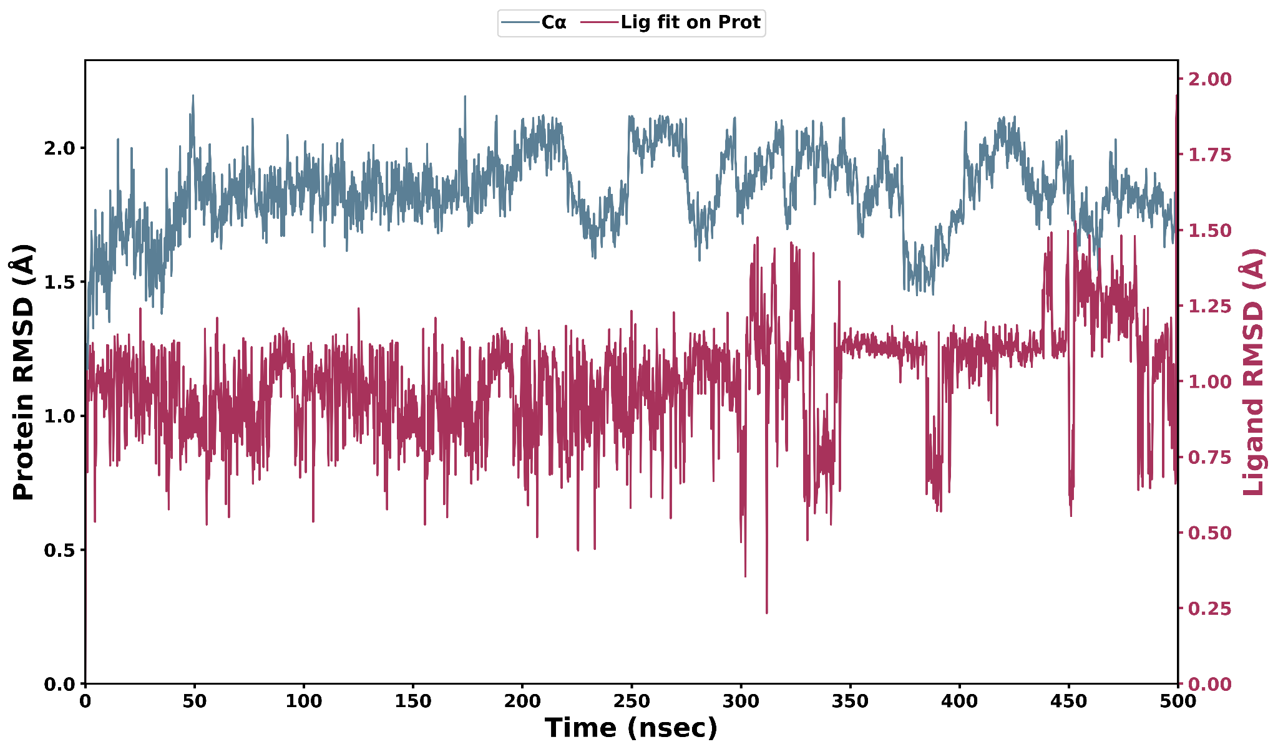
Fig S1: CID 44591548 RMSD

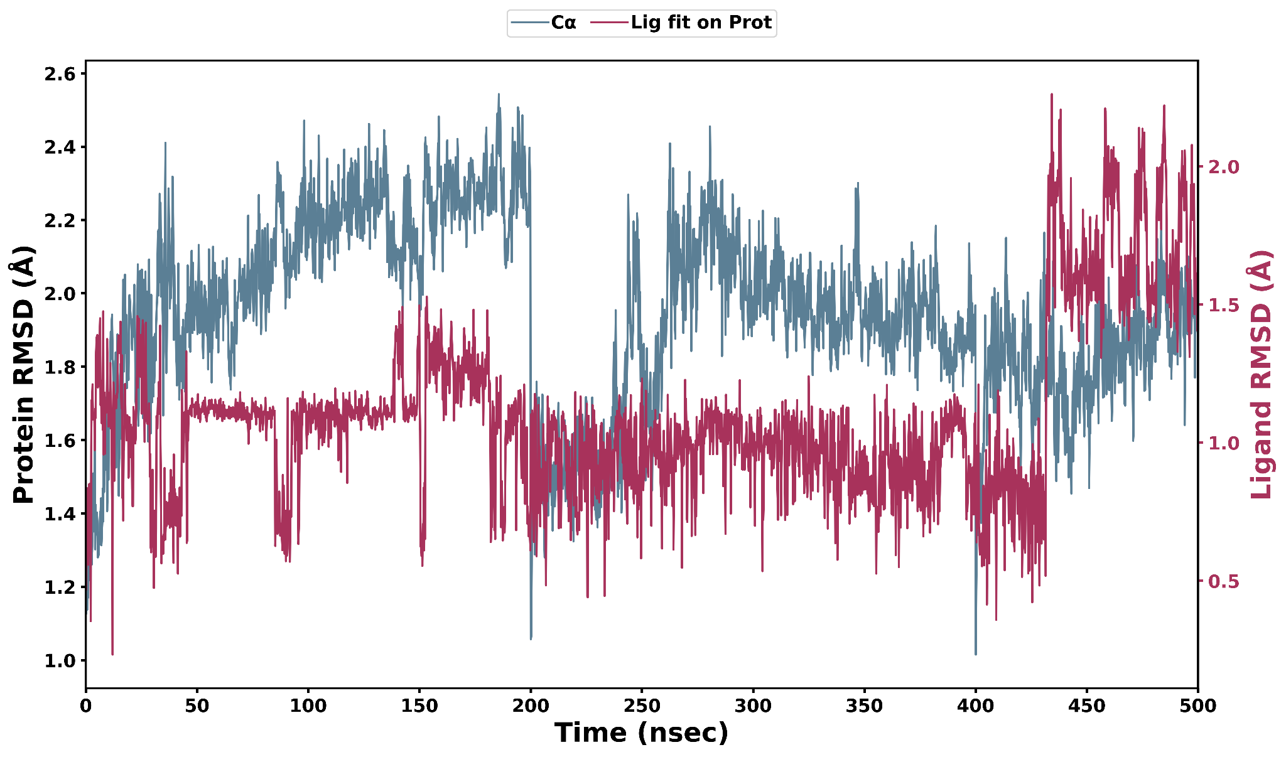
Fig S2: ZINC000150338755 RMSD
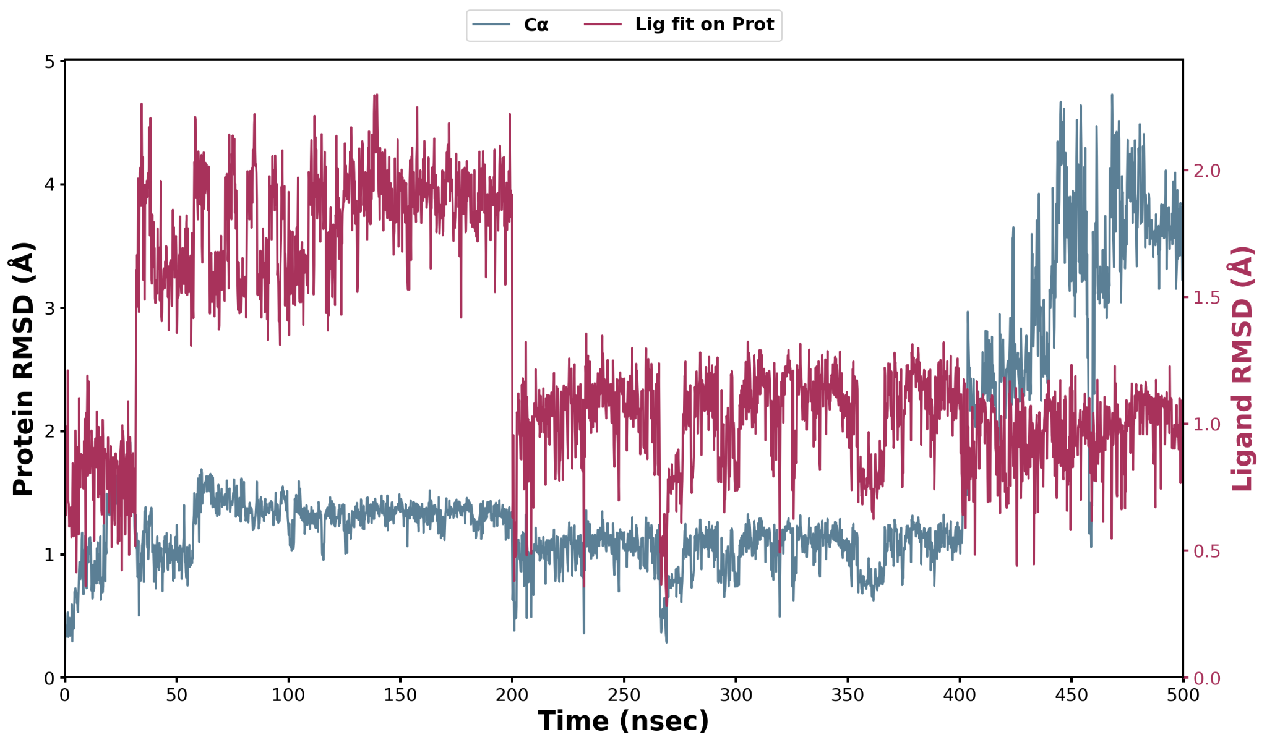
Fig S3: ZINC000003976838 RMSD

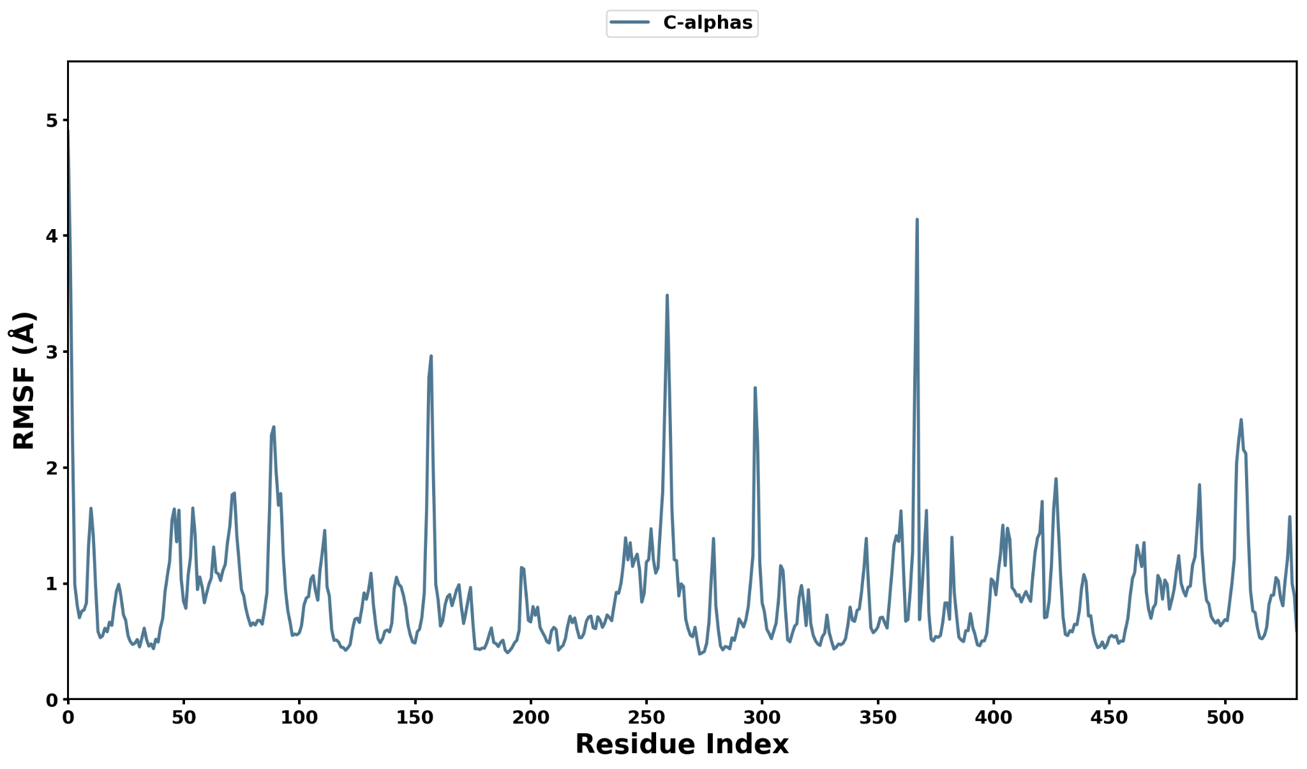
Fig S4: CID 44591548 RMSF
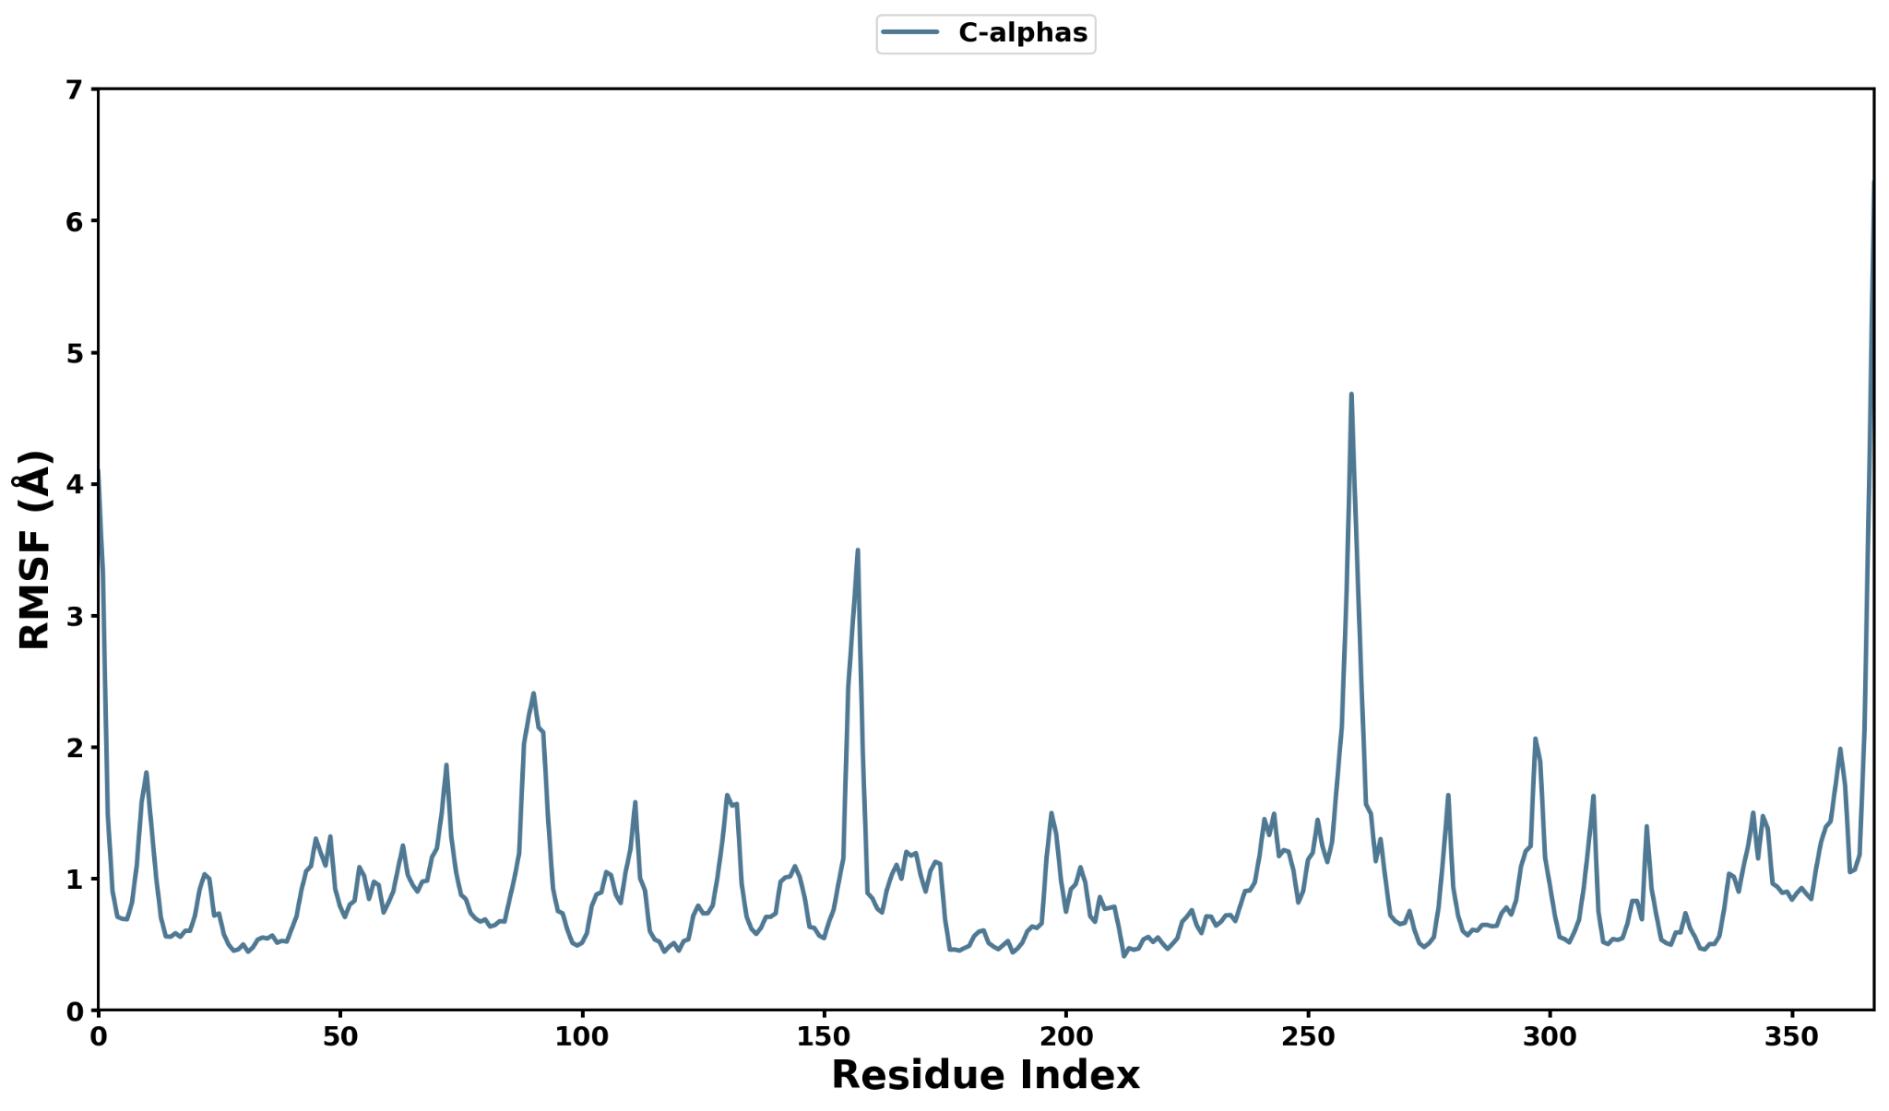
Fig S5: ZINC000150338755 RMSF
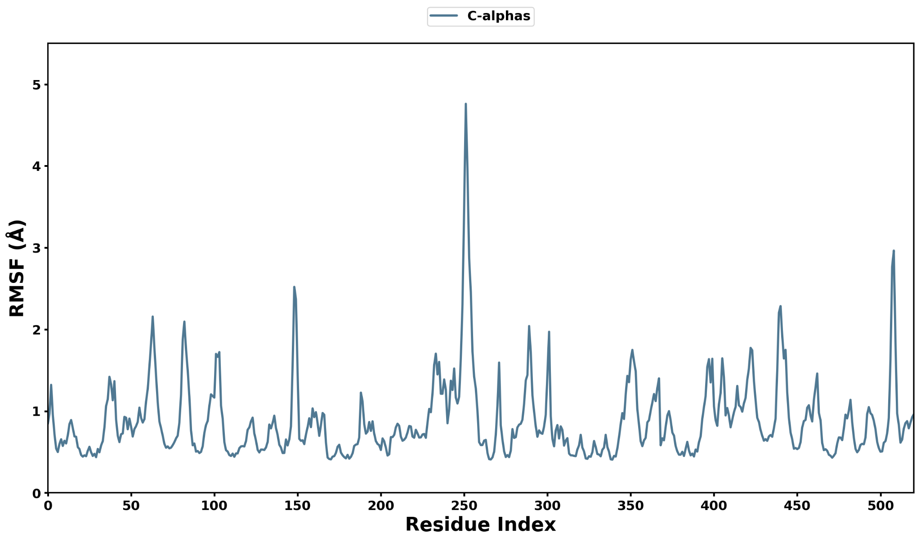
Fig S6: ZINC000003976838 RMSD

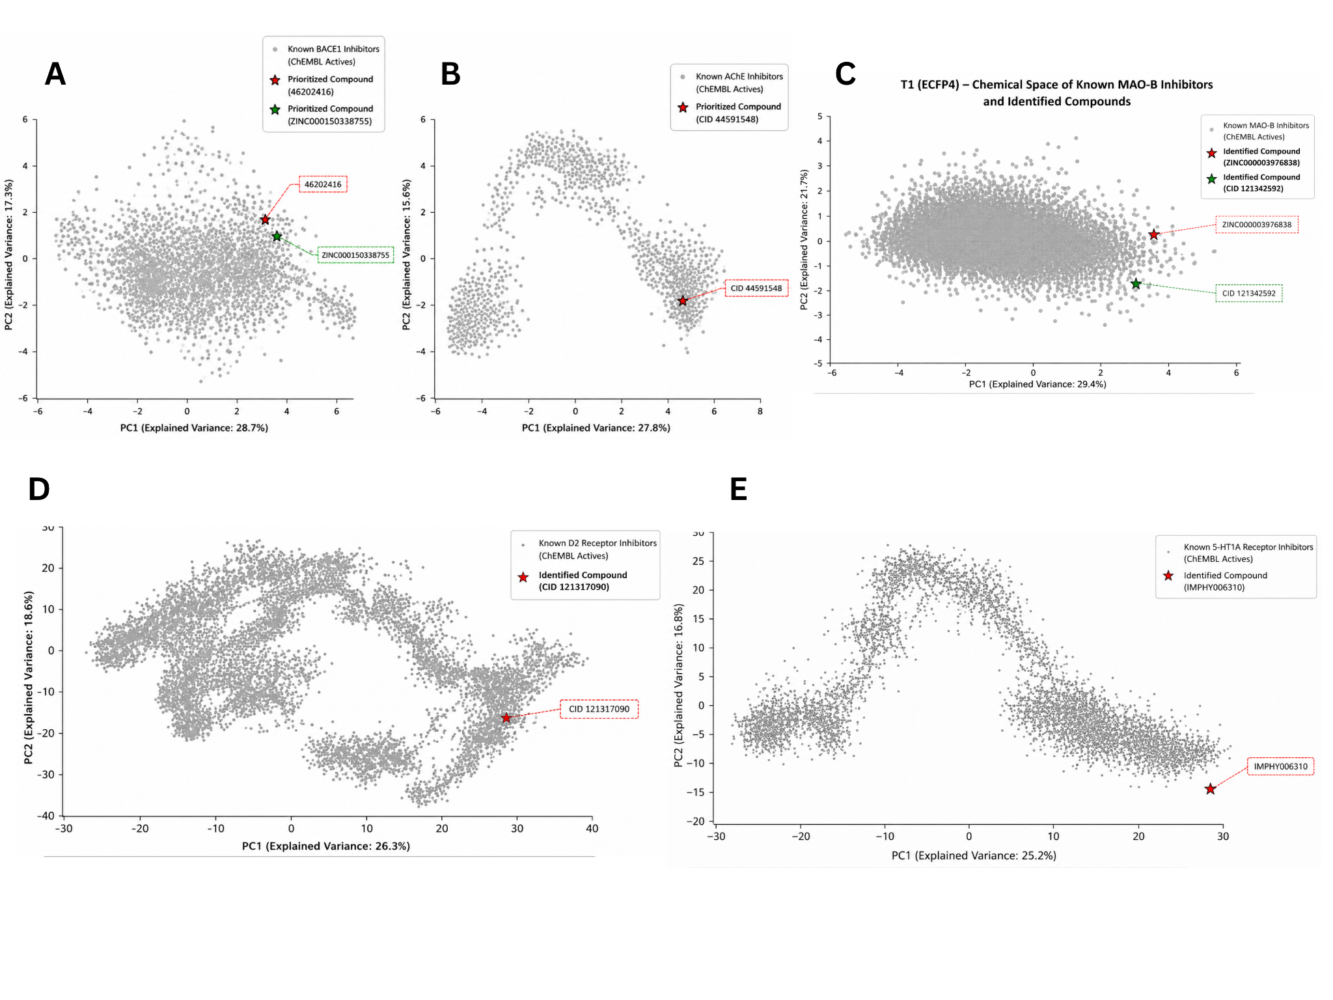
S7: Pca for final comppounds

